Insights project: Inquiry model Student name:__________________________
Date:___________________ Block: _________

Project name : Horses and Boots^

Observations and doodles
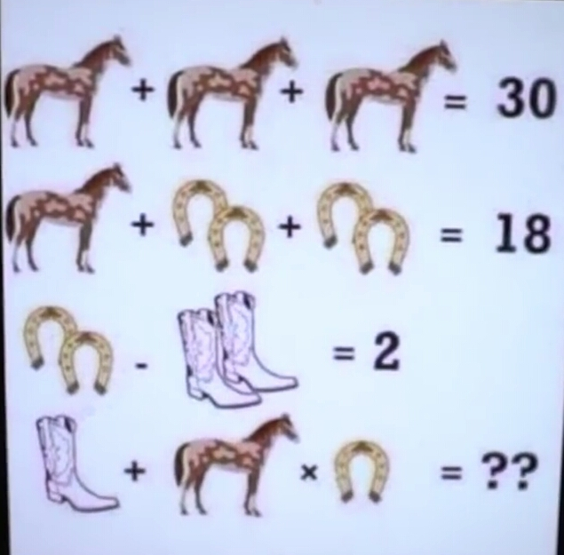

Wrong answers and guesses (Goldilocks)

Solve + explain

