Insights project: Inquiry model Student name:__________________________
Date:___________________ Block: _________

Project name : Cryptogram^

Question
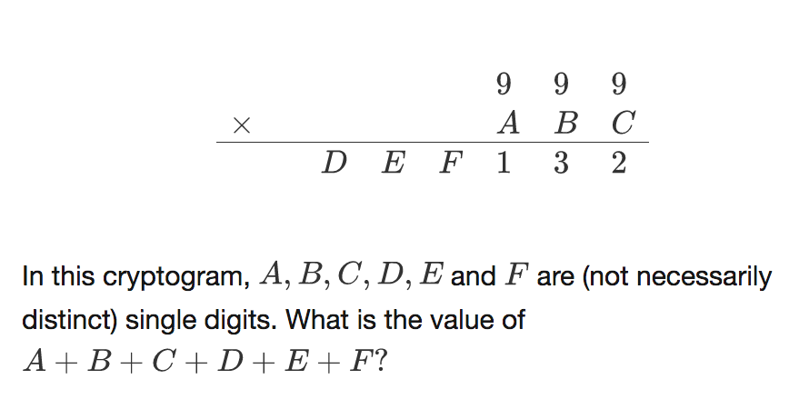

Solve + explain

