Insights project: Inquiry model Student name:__________________________
Date:___________________ Block: _________

Project name : Bag of Bigger numbers ^

Observations and doodles
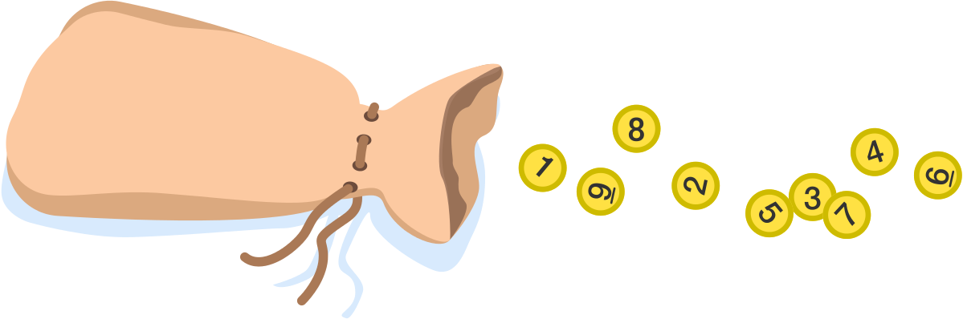
Ali and Zoe reach into a bag that they know contains nine lottery balls numbered 1-9. They each take one ball out to keep and they look at it secretly. Then, they make the following statements, in order:
Ali: "I don't know whose number is bigger."
Zoe: "I don't know whose number is bigger either."
Ali: "I still don't know whose number is bigger."
Zoe: "Now I know that my number is bigger!"
Assuming Ali and Zoe are perfectly logical, what is Zoe's smallest possible number?
Wrong answers and guesses (Goldilocks)

Solve + explain
(for your convenience, putting it again here)

Ali: "I don't know whose number is bigger."
Zoe: "I don't know whose number is bigger either."
Ali: "I still don't know whose number is bigger."
Zoe: "Now I know that my number is bigger!"

