Fun Multiple Graphs
I. For each of the below graphs (A-through-E), fill in the below table.
You CAN use your calculator to verify your graphs and results.
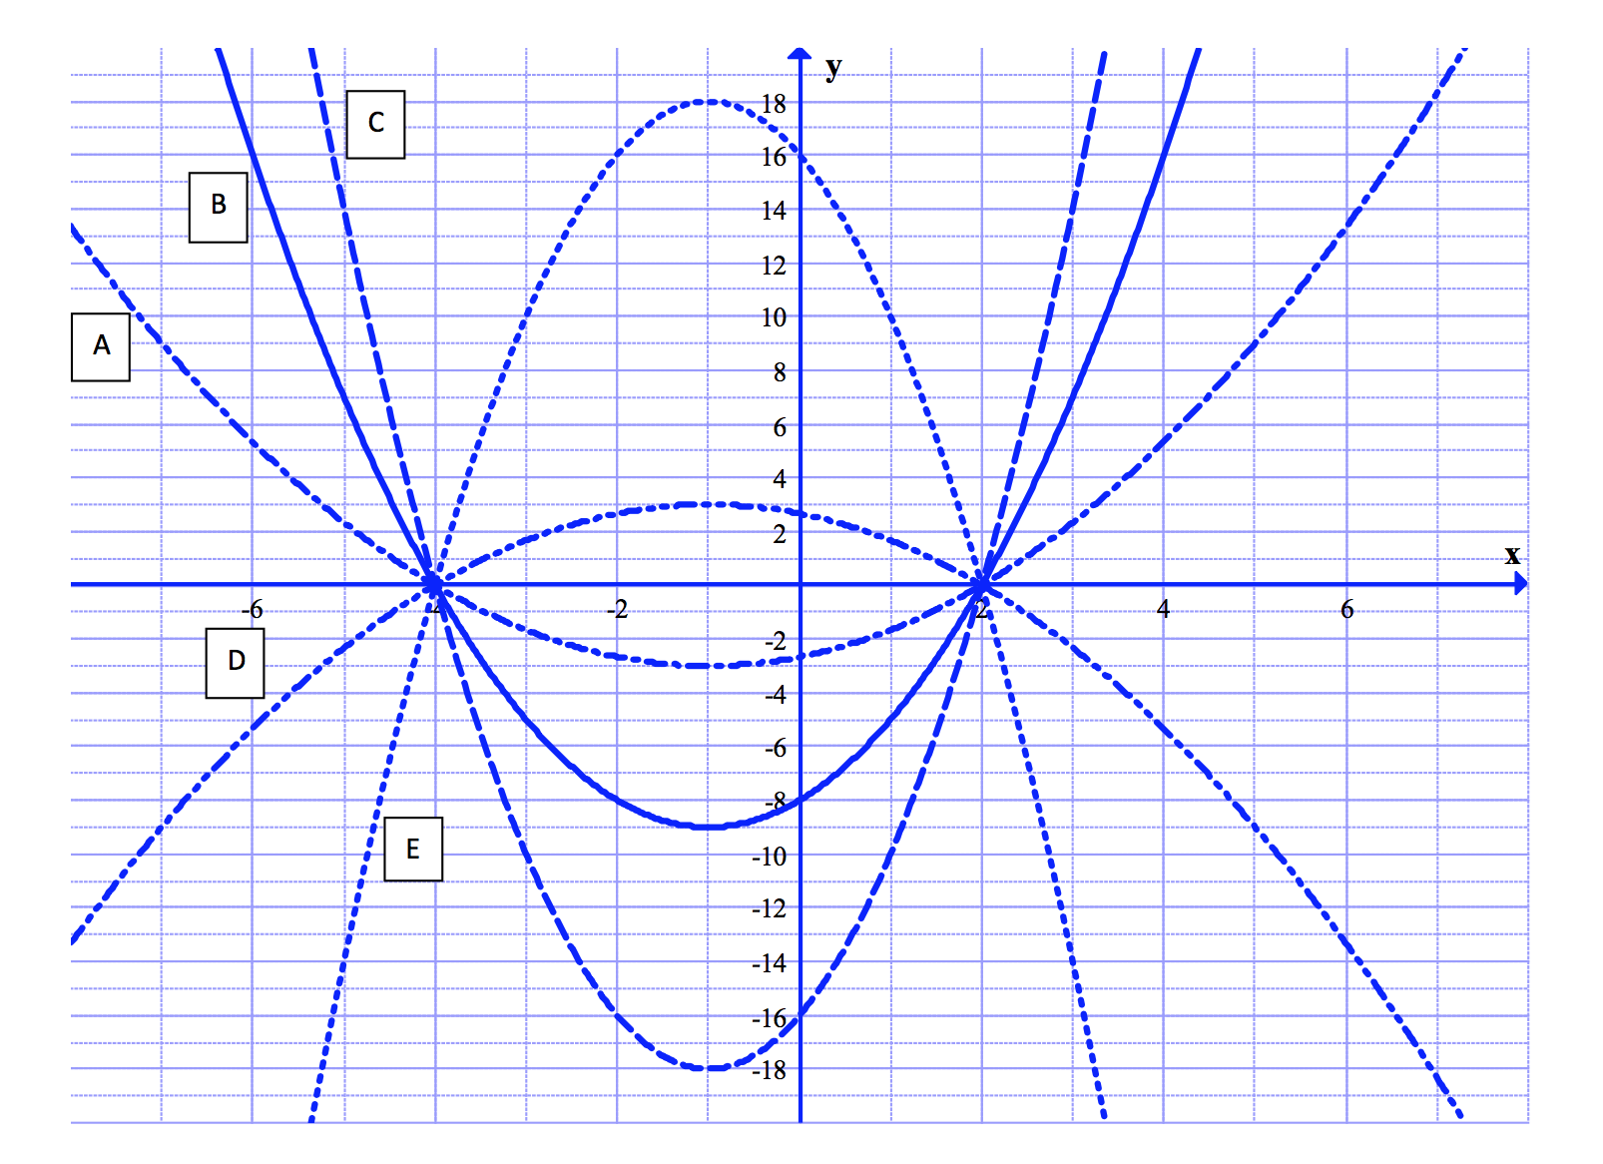
Graph | Zeros | Vertex | Write as  $$a{\left(x-h\right)}^{2}+k$$ | Write as factored form  $$a(x-x_{1})(x-x_{2})$$ | y-intercept  (Calculate)
A
B
C
D
E

I. For each of the below graphs (A-through-D), fill in the below table.
You CAN use your calculator to verify your graphs and results.
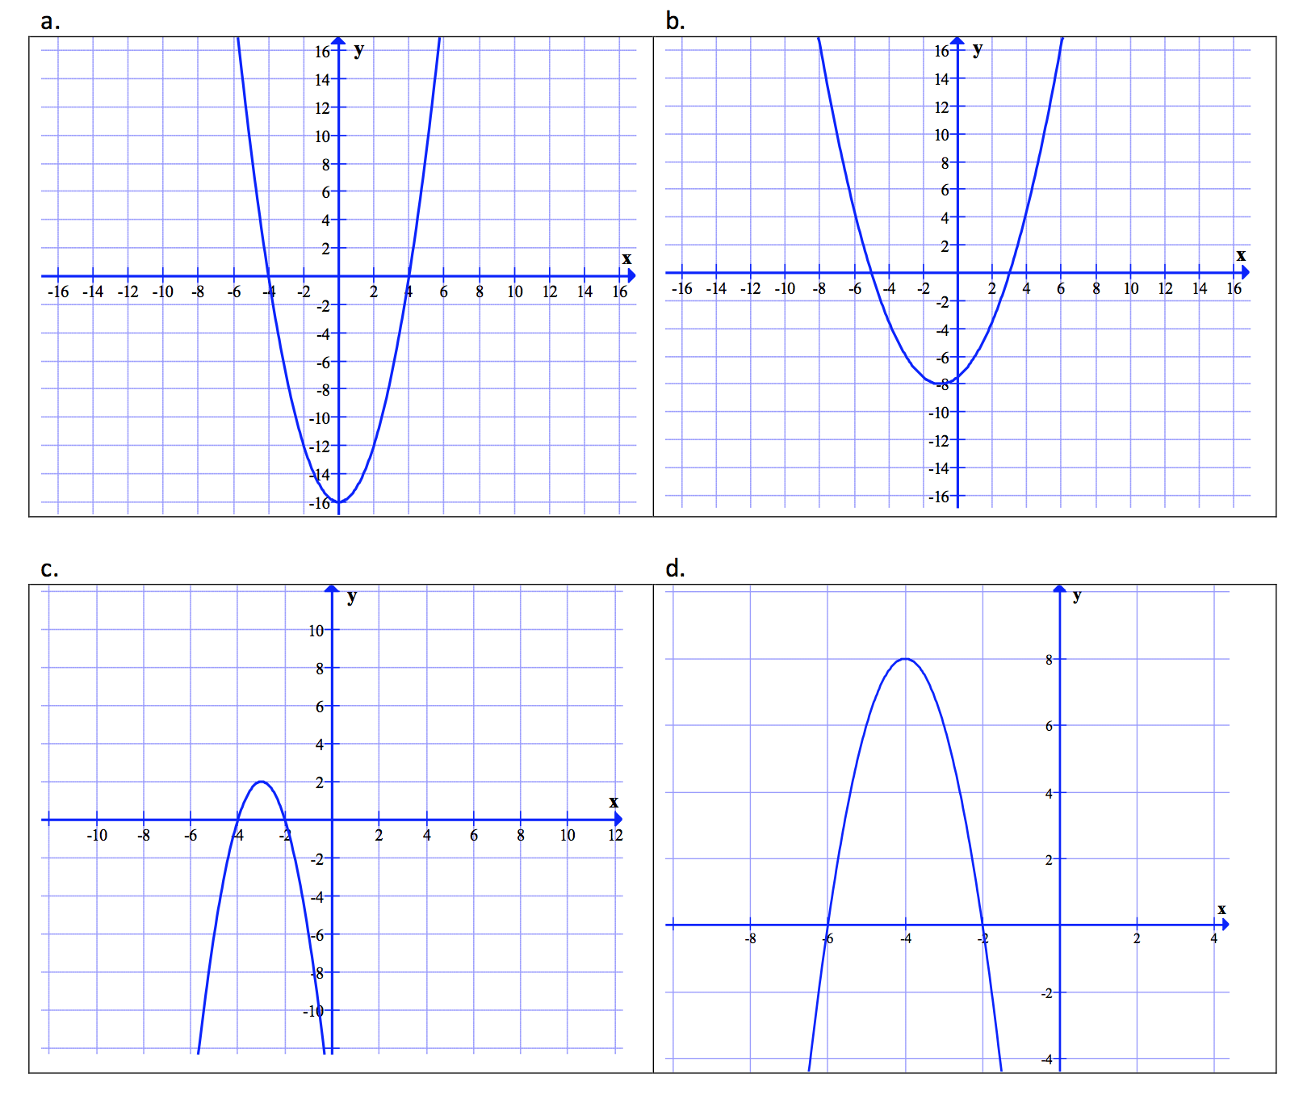
Graph | Zeros | Vertex | Write as  $$a{\left(x-h\right)}^{2}+k$$ | Write as factored form  $$a(x-x_{1})(x-x_{2})$$ | y-intercept  (Calculate)
A
B
C
D
=== End ===

