Name:_________________________________________ Block:___

Test: Unit8 and 9 (2/2)

Practice
Quadratic graphs.

There are 5 questions in this quiz, each of equal value.
Standard time for the quiz is 30 minutes.
Four operations calculator is allowed.

Question 1

Given the function $f\left(x\right)=\frac{1}{2}x^{2}-1$
a. Graph the function in the space below. You can use the table of values below for guidance.
b. Is the function Even? Odd? Neither? ___________________
c. Write the domain and range of the function:
D:__________________ R:____________________

d. Graph the function $f\left(x-4\right)+2$ . Please use a different color, or different line marks.
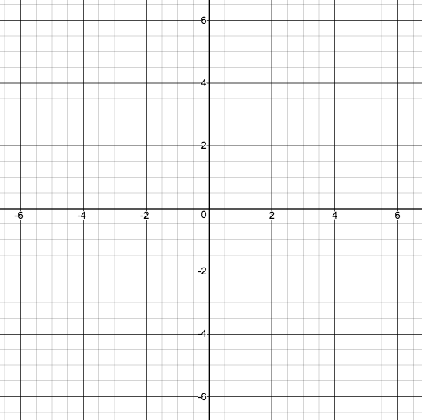
$$x$$ | $$f\left(x\right)=\frac{1}{2}x^{2}-1$$
-3
-2
-1
0
1
2
3

Question 2

Given the function $f\left(x\right)=-0.5⋅{\left(x-2\right)}^{2}+8$

a. Find the vertex : ___________________

b. Find the x-intercept(s): _______________________

c. Find the y-intercept(s): _______________________

d. Graph the function in the space given below, and note all the above points clearly on the graph.
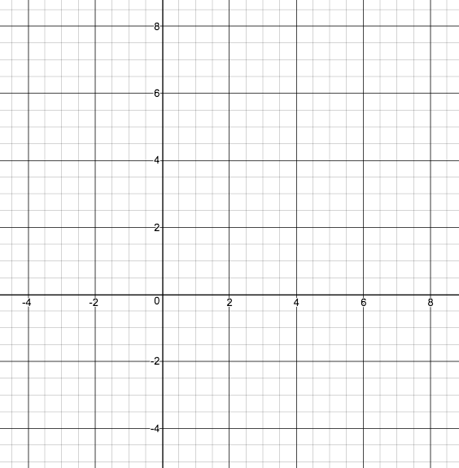

Use the table only if you feel compelled to
do so. Not for grading.
$$x$$ | $$f\left(x\right)=-0.5⋅{\left(x-2\right)}^{2}+8$$
2

Question 3

Given the function $f\left(x\right)={4x}^{2}+16x+7$

a. Write the function in vertex-form $a{\left(x-h\right)}^{2}+k$

b. Find the vertex : ___________________

c. Find the x-intercept(s): _______________________

d. Find the y-intercept(s): _______________________

e. Write the function in factored form $a⋅(x-x_{1})⋅(x-x_{2})$

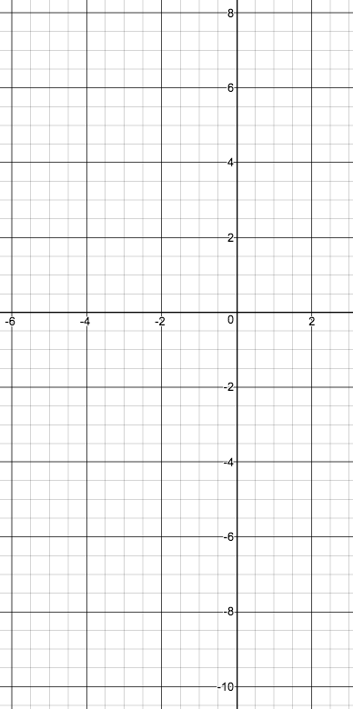
f. Graph the function in the space given below, and note all the above points clearly on the graph.

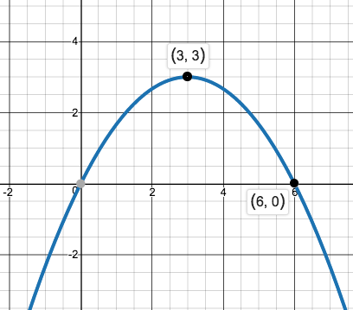
Question 4

Given the function as in the graph below.

a. Find the vertex from the graph: ___________________

b. Write the function in vertex-form $a{\left(x-h\right)}^{2}+k$

c. Write the function in standard quadratic form $ax^{2}+bx+c$

d. Write the function in factored form $a⋅(x-x_{1})⋅(x-x_{2})$

e. Find the x-intercept(s): _______________________

f. Find the y-intercept(s): _______________________

Question 5

The two sides of a right triangle add up to 10cm long.

a. What should be the length of each side in order to get minimum length of the hypotenuse ?

b. What should be the length of each side in order to get maximum length of the hypotenuse ?

== End of test ====

